

Software Requirement Specification

Project Code:

Document Code: SRS_V0.1

Record of change

*A - Added M - Modified D - Deleted

|  |  |  |  |  |
| --- | --- | --- | --- | --- |
| Effective Date | Changed Items | A* M, D | Change Description | New Version |
| 04/01/2017 |  |  |  | 0.1 |
|  |  |  |  |  |
|  |  |  |  |  |
|  |  |  |  |  |
|  |  |  |  |  |
|  |  |  |  |  |
|  |  |  |  |  |
|  |  |  |  |  |
|  |  |  |  |  |
|  |  |  |  |  |
|  |  |  |  |  |
|  |  |  |  |  |
|  |  |  |  |  |
|  |  |  |  |  |
|  |  |  |  |  |
|  |  |  |  |  |
|  |  |  |  |  |
|  |  |  |  |  |
|  |  |  |  |  |

SIGNATURE PAGE

**ORIGINATOR:** KienTX2 04/01/2017

Developer

**REVIEWERS:** <Name> <Date>

<Position>

<Name, if it’s needed> <Date>

<Position>

**APPROVAL:** <Name> <Date>

<Position>

TABLE OF CONTENTS

Table of Contents

1. Introdution 5

1.1 Purpose 5

1.2 Scope 5

1.3 Definitions, Acronyms, and Abbreviations 5

1.4 References 5

1.5 Overview 5

2. Overall Description 7

3. Specific Requirements 8

3.1 Functionality 8

3.2 Usability 92

3.3 Reliability 92

3.4 Performance 92

3.5 Supportability 92

3.6 Design Constraints 92

3.7 On-line User Documentation and Help System Requirements 92

3.8 Interfaces 92

3.9 Licensing Requirements 92

3.10 Legal, Copyright, and Other Notices 92

3.11 Applicable Standards 92

4. Supporting Information 93

# Introdution

## Purpose

Documentation for detailed specifications of functional and non-functional requirement for the system of a restaurant. This document is used as a template for design and development the system.

## Scope

The document is intended for Project Manager, Designer, Developer, Tester who will implement and test the software requirements. So it not only provides the ability to read and understand at a high level for those who are not specialized in engineering, but also provide full technical specification for developers and testers.

## Definitions, Acronyms, and Abbreviations

## References

## Overview

|  |  |  |  |  |  |
| --- | --- | --- | --- | --- | --- |
| **Functional Group** | | | **No** | **Functional** | **Note** |
| **System** | | | 1 | Log in |  |
| 2 | Log out |  |
| 3 | Forgot Password |  |
| 4 | Change Password |  |
| 5 | Home Page |  |
| **Product Management** | **Product** | | 6 | Add Product |  |
| 7 | Search Product |  |
| 8 | Update Product |  |
| 9 | Delete Product |  |
| **Product Category** | | 10 | Add Product Category |  |
| 11 | Search Product Category |  |
| 12 | Update Product Category |  |
| 13 | Delete Product Category |  |
| **Employee Management** | | | 14 | Add Employee |  |
| 15 | Search Employee |  |
| 16 | Update Employee Information |  |
| 17 | Delete Employee |  |
| **Promotion Management** | | | 18 | Create Promotion |  |
| 19 | Search Promotion |  |
| 20 | Update Promotion |  |
| **Customer Management** | | | 21 | Add Customer |  |
| 22 | Search Customer Information |  |
| 23 | Update Customer Information |  |
| 24 | Delete Customer |  |
| **Table Management** | | **Table** | 25 | Add Table |  |
| 26 | Search Table |  |
| 27 | Update Table |  |
| 28 | Delete Table |  |
| **Group Table** | 29 | Add Group Table |  |
| 30 | Search Group Table |  |
| 31 | Update Group Table |  |
| 32 | Delete Group Table |  |
| **Goods Receipt Management** | | | 33 | Create Goods Receipt |  |
| 34 | Search Goods Receipt |  |
| 35 | Show Goods Receipt Detail |  |
| 36 | Update Goods Receipt |  |
| 37 | Delete Goods Receipt |  |
| **Bill Management** | | | 38 | Show Bill Detail |  |

# Overall Description

# Specific Requirements

## 3.1 Functionality

### 3.1.1 Log In

|  |  |
| --- | --- |
| Description | Manager login to system. |
| Actor | Manager |
| Pre-condition | Was registered by administrator and correcspones to the role of that account. |
| Post-condition | Login success and display Home page with role of that account. |
| Data Table | Account |
| Usage Frequency | Often | Regular | Low |
| Criticality | High | Normal | Low |
| Denpendencies | N/A |

**Activity Flow**

|  |  |
| --- | --- |
| Actor | System |
| 1. Manager access to application | 2. System display Login Page. |
| 3. Manager input account and password |  |
| 4. Manager Press Button “Đăng nhập” | 5. System display Home Page with functional according to the account |

**Alternative Flow**

* Log in fail: System display notification: “Tài khoản hoặc mật khẩu không đúng”, and manager will try to log in again.
* If manager forgot password, manager can press on button “Quên mật khẩu?” to get back their password.
* System will display screen “Lấy lại mật khẩu” for user to get new password.

**Bussiness Rules**

|  |  |
| --- | --- |
| BR ID | Description |
| BR 1 | Username is invalid, must not contain special character, exp: ~, `, !, @, #, $, %, ^, &, *, (, ), _, -, +, =, :, ;, “, ‘, [, {, ], }, |, \, /, ?, <, >, “,”, “.” . |
| BR 2 | Password must have length from 6 to 30 character and must be contain at least one uppercase character, lowercase character and number and must not include special character : !, @, #.  Password must be transferred to character “*” to privacy. |
| BR 3 | If username and password is incorrect, system will notify error to manager and allow user to log in again |

**Wireframes**

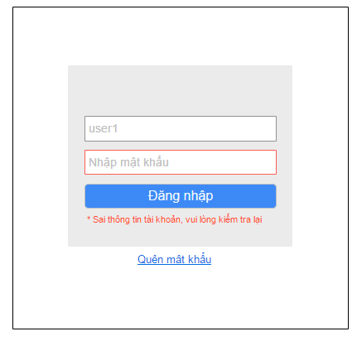

Wireframes 3.1.1 Login

**Wireframes Description**

|  |  |  |  |
| --- | --- | --- | --- |
| No | Control Name | Control Type | Description |
|  | | | |
| 1 | User name textbox | TextBox |  |
| 2 | Password textbox | TextBox |  |
| 3 | “Đăng nhập” button | Button |  |
| 4 | Error Notification | Label |  |
| 5 | “Quên Mật khẩu” | Button |  |

### 3.1.2 Log out

|  |  |
| --- | --- |
| Description | Manager log out of system |
| Actor | Manager |
| Pre-condition | Manager was logged in to system |
| Post-condition | Manager log out of system successfully |
| Data Table | N/A |
| Usage Frequency | Often | Regular | Low |
| Criticality | High | Normal | Low |
| Denpendencies | N/A |

**Activity Flow**

|  |  |
| --- | --- |
| Actor | System |
| 1. Manager press button Log out | 2. System display Log In screen |

**Alternative Flow**

N/A

**Bussiness Rules**

|  |  |
| --- | --- |
| BR ID | Description |
|  |  |

**Wireframes**

N/A

**Wireframes Description**

|  |  |  |  |
| --- | --- | --- | --- |
| No | Control Name | Control Type | Description |
|  |  |  |  |
|  |  |  |  |

### 3.1.3 Forgot Password

|  |  |
| --- | --- |
| Description | Manager can get new password when they are forget |
| Actor | Manager |
| Pre-condition | Manager press on button “Quên mật khẩu?” and they must remember username |
| Post-condition | Manager get new password from system |
| Data Table | N/A |
| Usage Frequency | Often | Regular | Low |
| Criticality | High | Normal | Low |
| Denpendencies | N/A |

**Activity Flow**

|  |  |
| --- | --- |
| Actor | System |
| 1. Manager press on button “Quên mật khẩu?” | 2. System display field to input username and retrieve password |
| 3. Manager input email or username which registration with administrator |  |
| 4. Manager press on button “Tìm” | 5. System looking for account on system and send an email with new password to manager |

**Alternative Flow**

* Wrong username or email: System will show notification that username or email is not exists in the system and allow manager to input again.

**Bussiness Rules**

|  |  |
| --- | --- |
| BR ID | Description |
| BR 1 | Email must have right format, contain ’@’ |

**Wireframes**

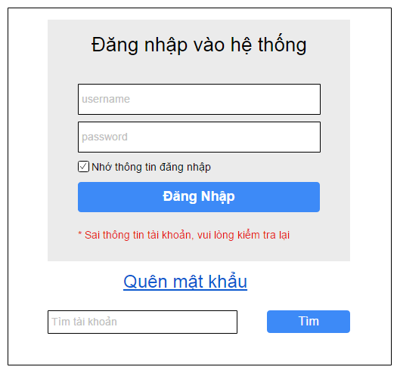

Wireframes 3.1.3 Forgot Password

**Wireframes Description**

|  |  |  |  |
| --- | --- | --- | --- |
| No | Control Name | Control Type | Description |
| 1 | Account, Email Input | Textbox |  |
| 2 | “Tìm” button | Button | System looking for account and send email with new pass |

### 3.1.4 Change Password

|  |  |
| --- | --- |
| Description | Manager can change their password |
| Actor | Manager |
| Pre-condition | Manager was logged in to system |
| Post-condition | Manager change their password successfully |
| Data Table | N/A |
| Usage Frequency | Often | Regular | Low |
| Criticality | High | Normal | Low |
| Denpendencies | N/A |

**Activity Flow**

|  |  |
| --- | --- |
| Actor | System |
| 1. Manager press on button “Đổi mật khẩu” | 2. System display dialog “Đổi mật khẩu” |
| 3. Manager input all the fields |  |
| 4. Manager press on button “Thay đổi mật khẩu” | 5. System change password and show notification password changed |

**Alternative Flow**

* Manager don’t input all required fields. System will notify manager “Vui lòng nhập các trường bắt buộc”.
* New Password and Confirm New Password Field not match. System will notify manager “Mật khẩu và Xác nhận mật khẩu không khớp”.
* New Password is the same with Old Password. System will notify manager “Mật khẩu mới không được giống mật khẩu cũ”.
* Password is invalid. System will notify manager “Vui lòng nhập mật khẩu chứa ít nhất một ký tự hoa, thường, số và không có ký tự đặc biệt”.

**Bussiness Rules**

|  |  |
| --- | --- |
| BR ID | Description |
| BR 1 | Password must have length from 6 to 30 character and must be contain at least one uppercase character, lowercase character and number and must not include special character : !, @, #. |
| BR 2 | New Password and Old Password must be the same. |

**Wireframes**

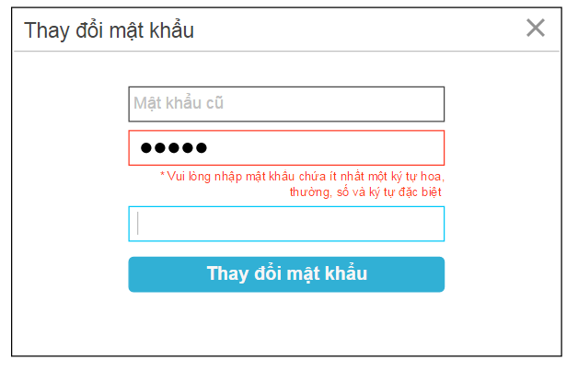

WireFrames 3.1.4 Change Password

**Wireframes Description**

|  |  |  |  |
| --- | --- | --- | --- |
| No | Control Name | Control Type | Description |
| 1 | Old Password | Textbox |  |
| 2 | New Password | Textbox |  |
| 3 | Retype Password | Textbox |  |
| 4 | “Thay đổi mật khẩu” button | Button |  |

### 3.1.5 Home Page

|  |  |
| --- | --- |
| Description | Display Home page with the role according to account |
| Actor | Manager |
| Pre-condition | Login Success |
| Post-condition | Display Home Page |
| Data Table | N/A |
| Usage Frequency | Often | Regular | Low |
| Criticality | High | Normal | Low |
| Denpendencies | N/A |

**Activity Flow**

|  |  |
| --- | --- |
| Actor | System |
| 1. Manager access to application | 2. System display Login Page. |
| 3. Manager input account and password |  |
| 4. Manager Press Button “Đăng nhập” | 5. System display Home Page with functional according to the account |

**Alternative Flow**

* Log in fail: Home Page will not display

**Bussiness Rules**

|  |  |
| --- | --- |
| BR ID | Description |
| BR 01 | Home Page will display features according to account |

**Wireframes**

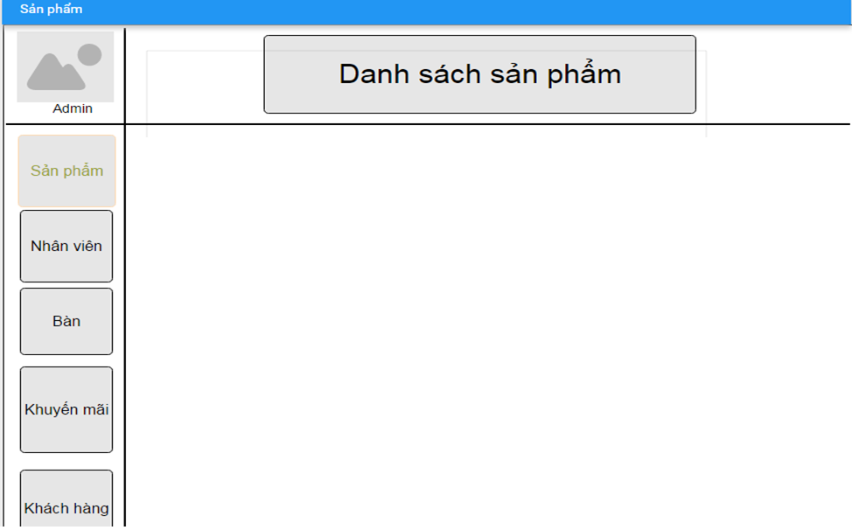

Wireframes 3.1.5 Home Page

**Wireframes Description**

|  |  |  |  |
| --- | --- | --- | --- |
| No | Control Name | Control Type | Description |
|  |  |  |  |
|  |  |  |  |

### 3.1.6 Add Product

|  |  |
| --- | --- |
| Description | Manager can add new product for their restaurant |
| Actor | Manager |
| Pre-condition | Manager log in to system and press on button “Thêm sản phẩm” in Product Page |
| Post-condition | New product added to database |
| Data Table | Product |
| Usage Frequency | Often | Regular | Low |
| Criticality | High | Normal | Low |
| Denpendencies | N/A |

**Activity Flow**

|  |  |
| --- | --- |
| Actor | System |
| 1. Manager access to application |  |
| 2. Manager access to Product Feature | 3. System display Product Screen |
| 4. Manager press on button “Thêm Sản Phẩm” | 5. System display Add Product Dialog |
| 6. Manager input all require fields |  |
| 7. Manager press on button “Save” | 8. System save new product to database |
|  | 9. System show dialog to notify successfully |

**Alternative Flow**

* Not input all require field: system will notify manager “Vui lòng nhập các trường bắt buộc”.
* Invalid input: system will notify manager with each field have invalid input.
* Product Name already exists in database: system will notify manager “Sản phẩm đã tồn tại”.

**Bussiness Rules**

|  |  |
| --- | --- |
| BR ID | Description |
| BR 1 | If manager have not input all required fields, system will show error |
| BR 2 | If have invalid field, system will show error below that field. |

**Wireframes**

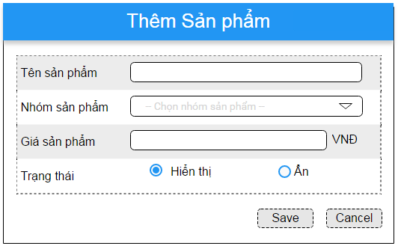

Wireframes 3.1.6 Add Product

**Wireframes Description**

|  |  |  |  |
| --- | --- | --- | --- |
| No | Control Name | Control Type | Description |
|  | | | |
| 1 | “Tên sản phẩm” Label | Label |  |
| 2 | Product Name | Textbox |  |
| 3 | “Nhóm sản phẩm” Label | Label |  |
| 4 | Product Category | Listbox |  |
| 5 | “Gía sản phẩm” Label | Label |  |
| 6 | Price | Textbox |  |
| 7 | “Trạng thái” Label | Label |  |
| 8 | Status | ComboBox |  |
| 9 | “Save” Button | Button |  |
| 10 | “Cancel” Button | Button |  |

### 3.1.7 Search Product

|  |  |
| --- | --- |
| Description | Manager list products they want to show |
| Actor | Manager |
| Pre-condition | Manager login to system, and access to Product Feature |
| Post-condition | System show list product by filter |
| Data Table | Product |
| Usage Frequency | Often | Regular | Low |
| Criticality | High | Normal | Low |
| Denpendencies | N/A |

**Activity Flow**

|  |  |
| --- | --- |
| Actor | System |
| 1. Manager access to application |  |
| 2. Manager access to Product Feature | 3. System display Product Screen |
| 4. Manager input to filter fields (not require) |  |
| 5. Manager press on button “Áp dụng” | 6. System search on database by filter fields |
|  | 7. System show products on list view |

**Alternative Flow**

* Not found product: System will show message under header of the list view.

**Bussiness Rules**

N/A

**Wireframes**

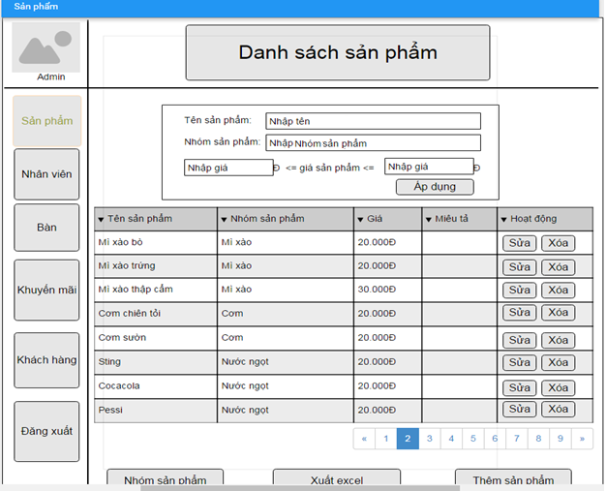

Wireframes 3.1.7 Search Product

**Wireframes Description**

|  |  |  |  |
| --- | --- | --- | --- |
| No | Control Name | Control Type | Description |
|  | | | |
| 1 | “Tên sản phẩm” Label | Label |  |
| 2 | Product Name | Textbox |  |
| 3 | “Nhóm sản phẩm” Label | Label |  |
| 4 | Product Category | Textbox |  |
| 5 | “Gía sản phẩm” Label | Label |  |
| 6 | Min Price | Textbox |  |
| 7 | Max Price | Textbox |  |
| 8 | “Áp dụng” button | Button | Perform search |
| 9 | Product Table | Table |  |
| 10 | “Nhóm sản phẩm” button | Button | Move to search product category |
| 11 | “Xuất Excel” button | Button | Export list product to excel file |
| 12 | “Thêm sản phẩm” button | Button | Move to add product screen |

### 3.1.8 Update Product

|  |  |
| --- | --- |
| Description | Manager update information of a product |
| Actor | Manager |
| Pre-condition | Manager login to system, access to Product Feature, search product and press on button “Sửa” beside product in product list |
| Post-condition | Product information will be update |
| Data Table | Product |
| Usage Frequency | Often | Regular | Low |
| Criticality | High | Normal | Low |
| Denpendencies | N/A |

**Activity Flow**

|  |  |
| --- | --- |
| Actor | System |
| 1. Manager press button “Sửa” beside product item in product list | 2. System display dialog Update Product Information |
| 3. Manager input fields |  |
| 4. Manager press on button “Save” | 5. System update product to database |
|  | 6. System show notification that product successfully updated |

**Alternative Flow**

* Not input all require field: system will notify manager “Vui lòng nhập các trường bắt buộc”.
* Invalid input: system will notify manager with each field have invalid input.

**Bussiness Rules**

|  |  |
| --- | --- |
| BR ID | Description |
| BR 1 | If manager have not input all required fields, system will show error |
| BR 2 | If have invalid field, system will show error below that field. |

**Wireframes**

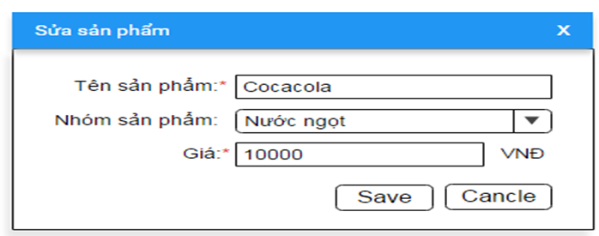

Wireframes 3.1.8 Update Product

**Wireframes Description**

|  |  |  |  |
| --- | --- | --- | --- |
| No | Control Name | Control Type | Description |
|  | | | |
| 1 | “Tên sản phẩm” Label | Label |  |
| 2 | Product name | Textbox |  |
| 3 | “Nhóm sản phẩm” Label | Label |  |
| 4 | Product Category | Listbox |  |
| 5 | “Gía sản phẩm” Label | Label |  |
| 6 | Price | Textbox |  |
| 7 | “Save” Button | Button |  |
| 8 | “Cancel” Button | Button |  |

### 3.1.9 Delete Product

|  |  |
| --- | --- |
| Description | Manager want to delete a product from their menu |
| Actor | Manager |
| Pre-condition | Manager login to system, access to Product Feature. search product and click on button “Xóa” beside product item in product list |
| Post-condition | Product is deleted from system |
| Data Table | Product |
| Usage Frequency | Often | Regular | Low |
| Criticality | High | Normal | Low |
| Denpendencies | N/A |

**Activity Flow**

|  |  |
| --- | --- |
| Actor | System |
| 1. Manager press on button “Xóa” beside product item | 2. System show dialog to confirm delete product |
| 3. Manager press on button “Có” | 4. System delete product |
|  | 5. System notify product successfully deleded |

**Alternative Flow**

* Manager press on Button “Không”: System will not delete product.

**Bussiness Rules**

|  |  |
| --- | --- |
| BR ID | Description |
|  |  |

**Wireframes**

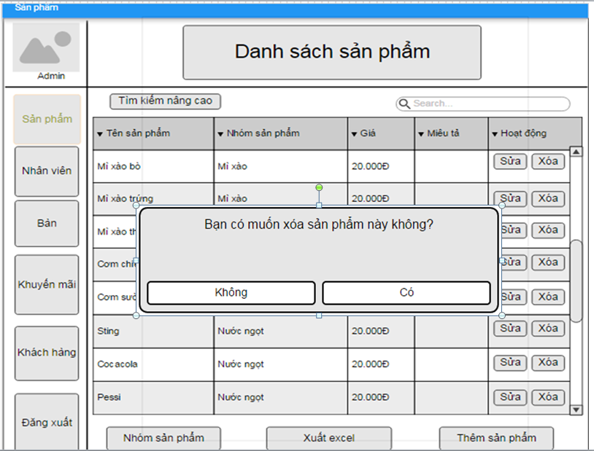

Wireframes 3.1.9 Delete Product

**Wireframes Description**

|  |  |  |  |
| --- | --- | --- | --- |
| No | Control Name | Control Type | Description |
|  | | | |
| 1 | “Có” button | Button |  |
| 2 | “Không” button | Button |  |

### 3.1.10 Add Product Category

|  |  |
| --- | --- |
| Description | Manager want to add new Product Category |
| Actor | Manager |
| Pre-condition | Manager login to system, access to Product Feature and press on button “Thêm Nhóm Sản Phẩm” |
| Post-condition | New product category will be add to system |
| Data Table | Product Group |
| Usage Frequency | Often | Regular | Low |
| Criticality | High | Normal | Low |
| Denpendencies | N/A |

**Activity Flow**

|  |  |
| --- | --- |
| Actor | System |
| 1. Manager access to application |  |
| 2. Manager access to Product Page | 3. System display Product Screen |
| 4. Manager press on button “Thêm Nhóm Sản Phẩm” | 5. System display Add Product Category Dialog |
| 6. Manager input product category name |  |
| 7. Manager press on button “Save” | 8. System save new product category to database |
|  | 9. System show dialog to notify successfully |

**Alternative Flow**

* Not input all require field: system will notify manager “Vui lòng nhập các trường bắt buộc”.
* Invalid input: system will notify manager with each field have invalid input.
* Product Category Name already exists in database: system will notify manager “Nhóm sản phẩm đã tồn tại”.

**Bussiness Rules**

|  |  |
| --- | --- |
| BR ID | Description |
| BR 1 | If manager have not input all required fields, system will show error |
| BR 2 | If have invalid field, system will show error below that field. |

**Wireframes**

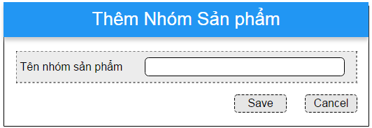

Wireframes 3.1.10 Add Product Category

**Wireframes Description**

|  |  |  |  |
| --- | --- | --- | --- |
| No | Control Name | Control Type | Description |
|  | | | |
| 1 | “Tên nhóm sản phẩm” Label | Label |  |
| 2 | Product category name | Textbox |  |
| 3 | “Save” Button | Button |  |
| 4 | “Cancel” Button | Button |  |

### 3.1.11 Search Product Category

|  |  |
| --- | --- |
| Description | Manager search for product category |
| Actor | Manager |
| Pre-condition | Manager log in to system, access to Product Feature |
| Post-condition | System show product category by filter |
| Data Table | Product Group |
| Usage Frequency | Often | Regular | Low |
| Criticality | High | Normal | Low |
| Denpendencies | N/A |

**Activity Flow**

|  |  |
| --- | --- |
| Actor | System |
| 1. Manager access to application |  |
| 2. Manager access to Product Feature | 3. System display Product Screen |
| 4. Manager press on button “Nhóm sản phẩm” | 5. System move to Product Category Page |
| 6. Manager input to filter fields (not require) |  |
| 7. Manager press on icon search | 8. System search on database by filter fields |
|  | 9. System show product categories on list view |

**Alternative Flow**

* Not found product: System will show error message under header of the list view.

**Bussiness Rules**

N/A

**Wireframes**

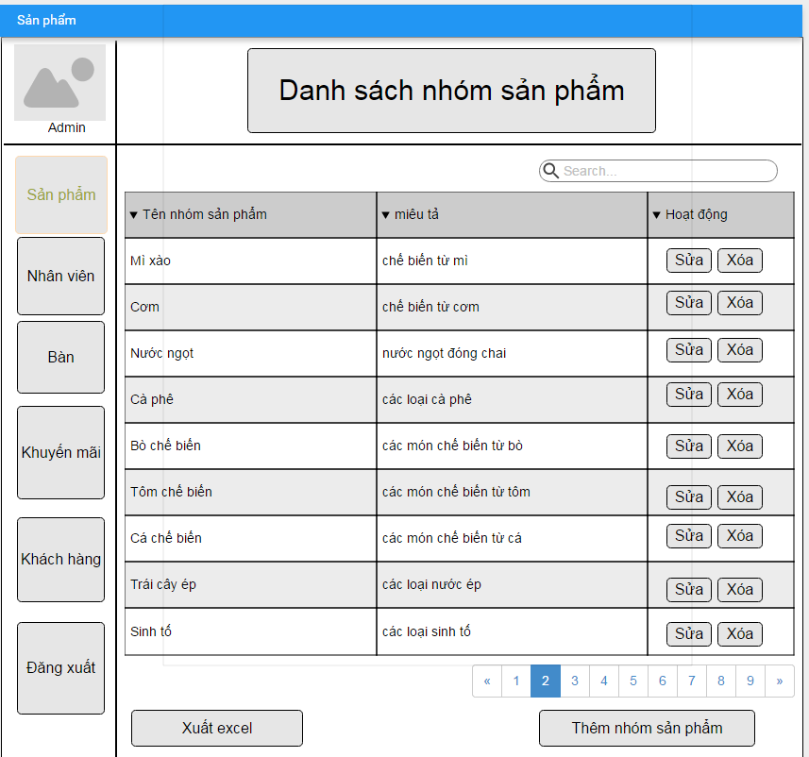

Wireframes 3.1.11 Search Product Category

**Wireframes Description**

|  |  |  |  |
| --- | --- | --- | --- |
| No | Control Name | Control Type | Description |
|  | | | |
| 1 | Product Category Tabel | Table |  |
| 2 | Search field | Textbox |  |
| 3 | Search icon | Button | Perform search |
| 4 | “Sửa” button | Button | Update product information |
| 5 | “Xóa” Button | Button | Delete product |
| 6 | “Thêm Nhóm sản phẩm” button | Button | Display add product category screen |
| 7 | “Xuất Excel” button | Button | Export list product to excel file |

### 3.1.12 Update Product Category

|  |  |
| --- | --- |
| Description | Update information of product category |
| Actor | Manager |
| Pre-condition | Manager login to system, access to Product Feature, search product and press on button “Sửa” beside product category in product category list |
| Post-condition | Product category will be update |
| Data Table | Product Group |
| Usage Frequency | Often | Regular | Low |
| Criticality | High | Normal | Low |
| Denpendencies | N/A |

**Activity Flow**

|  |  |
| --- | --- |
| Actor | System |
| 1. Manager press button “Sửa” beside product item in product list | 2. System display dialog Update Product Category Information |
| 3. Manager input fields |  |
| 4. Manager press on button “Save” | 5. System update product category to database |
|  | 6. System show notification that product category successfully updated |

**Alternative Flow**

* Not input all require field: system will notify manager “Vui lòng nhập các trường bắt buộc”.
* Invalid input: system will notify manager with each field have invalid input.

**Bussiness Rules**

|  |  |
| --- | --- |
| BR ID | Description |
| BR 1 | If manager have not input all required fields, system will show error |
| BR 2 | If have invalid field, system will show error below that field. |

**Wireframes**

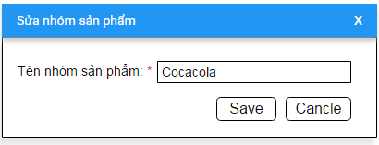

Wireframes 3.1.12 Update Product Category

**Wireframes Description**

|  |  |  |  |
| --- | --- | --- | --- |
| No | Control Name | Control Type | Description |
|  | | | |
| 1 | “Tên nhóm sản phẩm” Label | Label | Required |
| 2 | Product Category name | Textbox |  |
| 3 | “Save” button | Button |  |
| 4 | “Cancel” button | Button |  |

### 3.1.13 Delete Product Category

|  |  |
| --- | --- |
| Description | Manager want to delete a product category |
| Actor | Manager |
| Pre-condition | Manager login to system, access to Product Category Page. search product category and click on button “Xóa” beside product item in product category list |
| Post-condition | Product category is deleted from system |
| Data Table | Product Group |
| Usage Frequency | Often | Regular | Low |
| Criticality | High | Normal | Low |
| Denpendencies | N/A |

**Activity Flow**

|  |  |
| --- | --- |
| Actor | System |
| 1. Manager press on button “Xóa” beside product category item | 2. System show dialog to confirm delete product category |
| 3. Manager press on button “Có” | 4. System delete product category |
|  | 5. System notify product category successfully deleded |

**Alternative Flow**

* Manager press on Button “Không”: System will not delete product category.

**Bussiness Rules**

|  |  |
| --- | --- |
| BR ID | Description |
|  |  |

**Wireframes**

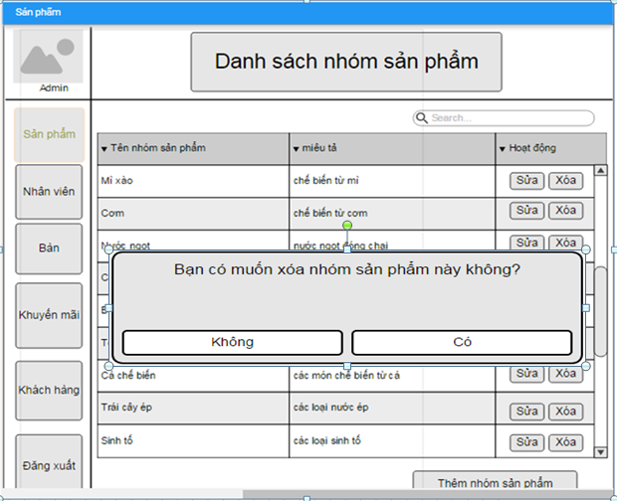

Wireframes 3.1.13 Delete Product Category

**Wireframes Description**

|  |  |  |  |
| --- | --- | --- | --- |
| No | Control Name | Control Type | Description |
|  | | | |
| 1 | “Có” button | Button |  |
| 2 | “Không” button | Button |  |

### 3.1.14 Add Employee

|  |  |
| --- | --- |
| Description | Manager add a new employee information of their restaurant |
| Actor | Manager |
| Pre-condition | Manager login to system, access to Employee Feature. Manager press on button “Thêm Nhân Viên” |
| Post-condition | New employee will be added |
| Data Table | Employee |
| Usage Frequency | Often | Regular | Low |
| Criticality | High | Normal | Low |
| Denpendencies | N/A |

**Activity Flow**

|  |  |
| --- | --- |
| Actor | System |
| 1. Manager access to application |  |
| 2. Manager access to Employee Feature | 3. System display Employee Screen |
| 4. Manager press on button “Thêm Nhân Viên” | 5. System display Add New Employee Dialog |
| 6. Manager input all require fields |  |
| 7. Manager press on button “Save” | 8. System save new employee to database |
|  | 9. System show dialog to notify successfully |

**Alternative Flow**

* Not input all require field: system will notify manager “Vui lòng nhập các trường bắt buộc”.
* Invalid input: system will notify manager with each field have invalid input.

**Bussiness Rules**

|  |  |
| --- | --- |
| BR ID | Description |
| BR 1 | If manager have not input all required fields, system will show error |
| BR 2 | If have invalid field, system will show error below that field. |

**Wireframes**

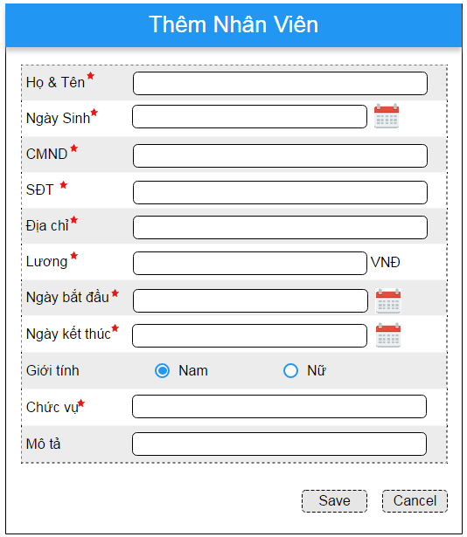

Wireframes 3.1.14 Add Employee

**Wireframes Description**

|  |  |  |  |
| --- | --- | --- | --- |
| No | Control Name | Control Type | Description |
|  | | | |
| 1 | “Họ và tên” Label | Label |  |
| 2 | Employee Name | Textbox |  |
| 3 | “Ngày sinh” Label | Label |  |
| 4 | Birthday | Listbox |  |
| 5 | “CMND” Label | Label |  |
| 6 | Identity Card | Textbox |  |
| 7 | “Số điện thoại” Label | Label |  |
| 8 | Phone number | ComboBox |  |
| 9 | “Địa chỉ” Label | Label |  |
| 10 | Address | Textbox |  |
| 11 | “Lương” Label | Label |  |
| 12 | Salary | Textbox |  |
| 13 | “Ngày bắt đầu” Label | Label |  |
| 14 | Start day | Textbox |  |
| 15 | “Ngày kết thúc” Label | Label |  |
| 16 | End day | Textbox |  |
| 17 | “Giới tính” Label | Label |  |
| 18 | Gender | RadioBox |  |
| 19 | “Chức vụ” Label | Label |  |
| 20 | Position | Textbox |  |
| 21 | “Mô tả” Label | Label |  |
| 22 | Description | Textbox |  |
| 23 | “Save” Button | Button |  |
| 24 | “Cancel” Button | Button |  |

### 3.1.15 Search Employee

|  |  |
| --- | --- |
| Description | Manager want to search for employee and see their information |
| Actor | Manager |
| Pre-condition | Manager login to system, access to Employee Feature |
| Post-condition | System display list employee by filter |
| Data Table | Employee |
| Usage Frequency | Often | Regular | Low |
| Criticality | High | Normal | Low |
| Denpendencies | N/A |

**Activity Flow**

|  |  |
| --- | --- |
| Actor | System |
| 1. Manager access to application |  |
| 2. Manager access to Employee Feature | 3. System display Employee Screen |
| 4. Manager input to filter fields (not require) |  |
| 5. Manager press on button “Áp dụng” | 6. System search on database by filter fields |
|  | 7. System show employees on list view |

**Alternative Flow**

* Not found employee: System will show message under header of the list view.

**Bussiness Rules**

N/A

**Wireframes**

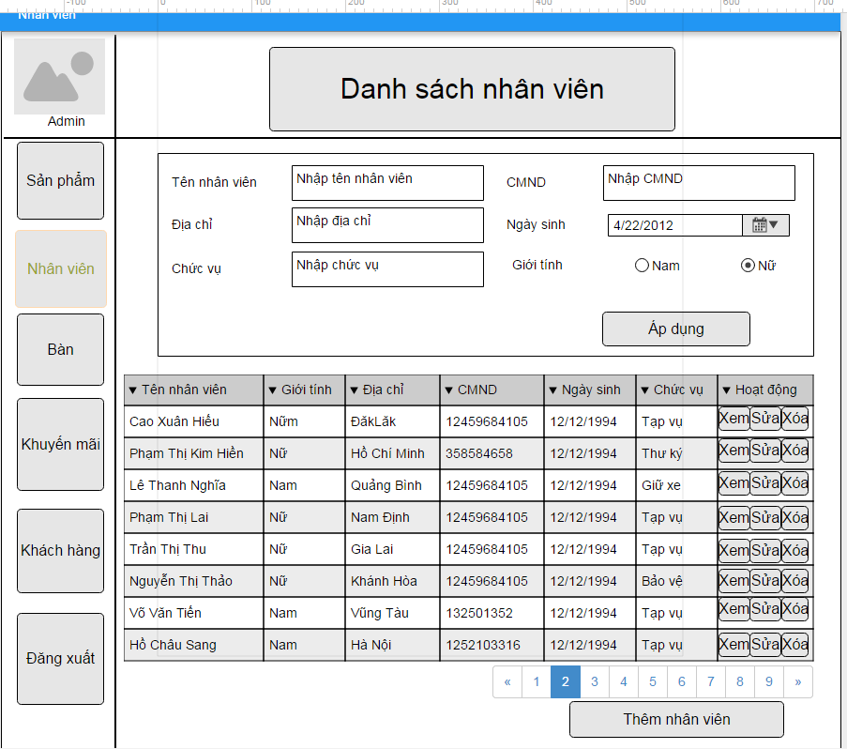

Wireframes 3.1.15 Seach Employee

**Wireframes Description**

|  |  |  |  |
| --- | --- | --- | --- |
| No | Control Name | Control Type | Description |
|  | | | |
| 1 | “Tên nhân viên” Label | Label |  |
| 2 | Name | Textbox |  |
| 3 | “CMND” Label | Label |  |
| 4 | Identity Card | Textbox |  |
| 5 | “Địa chỉ” Label | Label |  |
| 6 | Address | Textbox |  |
| 7 | “Ngày sinh” Label | Label |  |
| 8 | Birthday | Textbox |  |
| 9 | “Chức vụ” Label | Label |  |
| 10 | Position | Textbox |  |
| 11 | “Giới tính” Label | Label |  |
| 12 | Gender | RadioBox |  |
| 13 | “Áp dụng” button | Button |  |
| 14 | Employee Table | Table |  |
| 15 | “Thêm nhân viên” buttton | Button |  |

### 3.1.16 Update Employee Information

|  |  |
| --- | --- |
| Description | Manager update information of employee of their restaurant |
| Actor | Manager |
| Pre-condition | Manager login to system, access to Employee Feature, search for employee and press on button “Sửa” beside employee in employee list |
| Post-condition | Employee information updated |
| Data Table | Employee |
| Usage Frequency | Often | Regular | Low |
| Criticality | High | Normal | Low |
| Denpendencies | N/A |

**Activity Flow**

|  |  |
| --- | --- |
| Actor | System |
| 1. Manager press button “Sửa” beside product item in employee list | 2. System display dialog Update Employee Information |
| 3. Manager input fields |  |
| 4. Manager press on button “Save” | 5. System update employee to database |
|  | 6. System show notification that employee successfully updated |

**Alternative Flow**

* Not input all require field: system will notify manager “Vui lòng nhập các trường bắt buộc”.
* Invalid input: system will notify manager with each field have invalid input.

**Bussiness Rules**

|  |  |
| --- | --- |
| BR ID | Description |
| BR 1 | If manager have not input all required fields, system will show error |
| BR 2 | If have invalid field, system will show error below that field. |

**Wireframes**

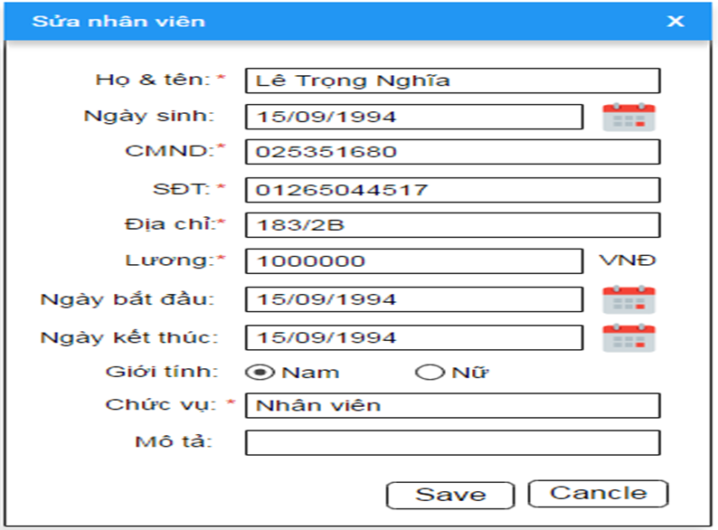

Wireframes 3.1.16 Update Employee Information

**Wireframes Description**

|  |  |  |  |
| --- | --- | --- | --- |
| No | Control Name | Control Type | Description |
|  | | | |
| 1 | “Họ và tên” Label | Label |  |
| 2 | Employee Name | Textbox |  |
| 3 | “Ngày sinh” Label | Label |  |
| 4 | Birthday | Listbox |  |
| 5 | “CMND” Label | Label |  |
| 6 | Identity Card | Textbox |  |
| 7 | “Số điện thoại” Label | Label |  |
| 8 | Phone number | ComboBox |  |
| 9 | “Địa chỉ” Label | Label |  |
| 10 | Address | Textbox |  |
| 11 | “Lương” Label | Label |  |
| 12 | Salary | Textbox |  |
| 13 | “Ngày bắt đầu” Label | Label |  |
| 14 | Start day | Textbox |  |
| 15 | “Ngày kết thúc” Label | Label |  |
| 16 | End day | Textbox |  |
| 17 | “Giới tính” Label | Label |  |
| 18 | Gender | RadioBox |  |
| 19 | “Chức vụ” Label | Label |  |
| 20 | Position | Textbox |  |
| 21 | “Mô tả” Label | Label |  |
| 22 | Description | Textbox |  |
| 23 | “Save” Button | Button |  |
| 24 | “Cancel” Button | Button |  |

### 3.1.17 Delete Employee

|  |  |
| --- | --- |
| Description | Manager delete an employee |
| Actor | Manager |
| Pre-condition | Manager login to system, access to Employee Feature, and press on button “Xóa” beside employee row in employee list |
| Post-condition | Employee will be deleted from database |
| Data Table | Employee |
| Usage Frequency | Often | Regular | Low |
| Criticality | High | Normal | Low |
| Denpendencies | N/A |

**Activity Flow**

|  |  |
| --- | --- |
| Actor | System |
| 1. Manager press on button “Xóa” beside employee item | 2. System show dialog to confirm delete |
| 3. Manager press on button “Có” | 4. System delete employee |
|  | 5. System notify employee successfully deleded |

**Alternative Flow**

* Manager press on Button “Không”: System will not delete employee.

**Bussiness Rules**

N/A

**Wireframes**

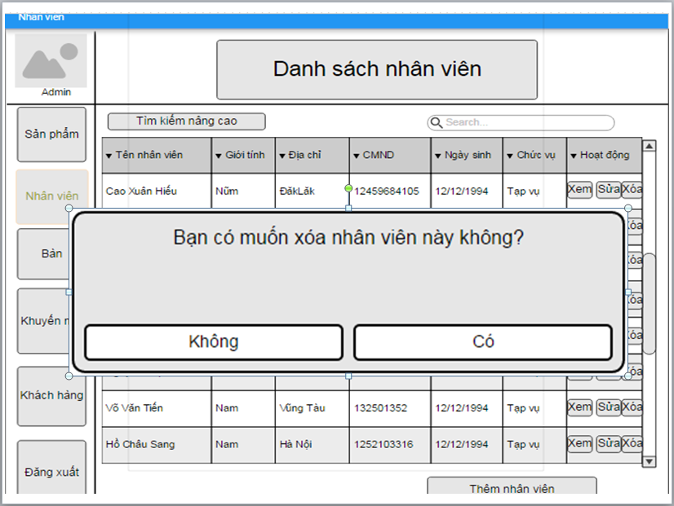

WireFrames 3.1.16 Delete Employee

**Wireframes Description**

|  |  |  |  |
| --- | --- | --- | --- |
| No | Control Name | Control Type | Description |
|  | | | |
| 1 | “Có” button | Button |  |
| 2 | “Không” button | Button |  |

### 3.1.18 Create Promotion

|  |  |
| --- | --- |
| Description | Manager create new promotion for restaurant |
| Actor | Manager |
| Pre-condition | Manager login to system, access to Promotion Feature, and press on button Add |
| Post-condition | New promotion will be created |
| Data Table | Promotion |
| Usage Frequency | Often | Regular | Low |
| Criticality | High | Normal | Low |
| Denpendencies | N/A |

**Activity Flow**

|  |  |
| --- | --- |
| Actor | System |
| 1. Manager access to application |  |
| 2. Manager access to Promotion Feature | 3. System display Promotion Screen |
| 4. Manager press on button “Add” | 5. System display Add New Promotion Dialog |
| 6. Manager input all require fields |  |
| 7. Manager press on button “Thêm chi tiết” | 8. System dislay Add Promotion Detail Dialog |
| 9. Manager press on button “Save” | 10. System save new promotion to database |
|  | 11. System show dialog to notify successfully |

**Alternative Flow**

* Not input all require field: system will notify manager “Vui lòng nhập các trường bắt buộc”.
* Invalid input: system will notify manager with each field have invalid input.
* Manager press on button “Hủy”: promotion will not be save.

**Bussiness Rules**

|  |  |
| --- | --- |
| BR ID | Description |
| BR 1 | If manager have not input all required fields, system will show error |
| BR 2 | If have invalid field, system will show error below that field. |
| BR 3 | Start day must smaller than end date |

**Wireframes**

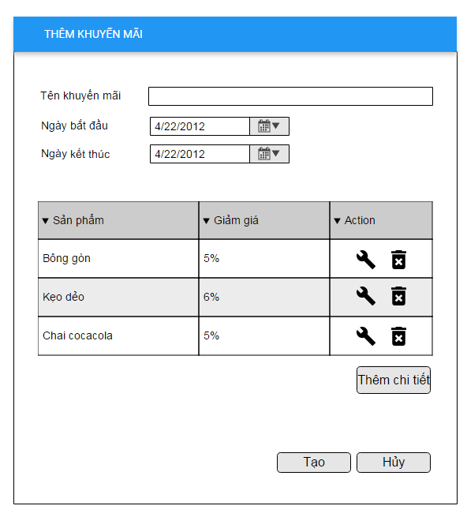

Wireframes 3.1.18.1 Create Promotion

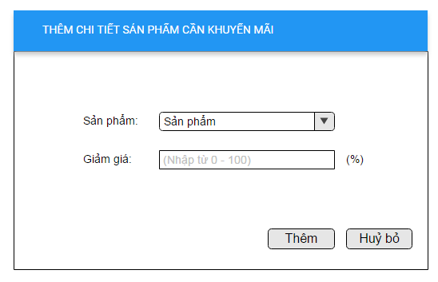

Wireframes 3.1.18.2 Add Promotion Detail

**Wireframes Description**

|  |  |  |  |
| --- | --- | --- | --- |
| No | Control Name | Control Type | Description |
|  | | | |
| 1 | “Tên khuyến mãi” Label | Label |  |
| 2 | Promotion name | Textbox |  |
| 3 | “Ngày bắt đầu” Label | Label |  |
| 4 | Start date | Textbox |  |
| 5 | “Ngày kết thúc” Label | Label |  |
| 6 | End date | Textbox |  |
| 7 | Promotion detail | Table |  |
| 8 | “Thêm chi tiết” button | Button |  |
| 9 | “Tạo” button | Button |  |
| 10 | “Hủy” button | Button |  |
| 11 | “Sản phẩm” Label | Label |  |
| 12 | Product | Combobox |  |
| 13 | “Giảm giá” Label | Label |  |
| 14 | Discount | Textbox |  |
| 15 | “Thêm” button | Button |  |
| 16 | “Hủy bỏ” button | Button |  |

### 3.1.19 Search Promotion

|  |  |
| --- | --- |
| Description | Manager search for promotion in system |
| Actor | Manager |
| Pre-condition | Manager log in to system, access to Promotion Feature |
| Post-condition | System show promotion to list promotion view |
| Data Table | Promotion |
| Usage Frequency | Often | Regular | Low |
| Criticality | High | Normal | Low |
| Denpendencies | N/A |

**Activity Flow**

|  |  |
| --- | --- |
| Actor | System |
| 1. Manager access to application |  |
| 2. Manager access to Promotion Feature | 3. System display Promotion Screen |
| 4. Manager input to filter fields (not require) |  |
| 5. Manager press on button “Tìm kiếm” | 6. System search on database by filter fields |
|  | 7. System show promotions on list view |

**Alternative Flow**

* Not found promotion: System will show message under header of the list view.

**Bussiness Rules**

N/A

**Wireframes**

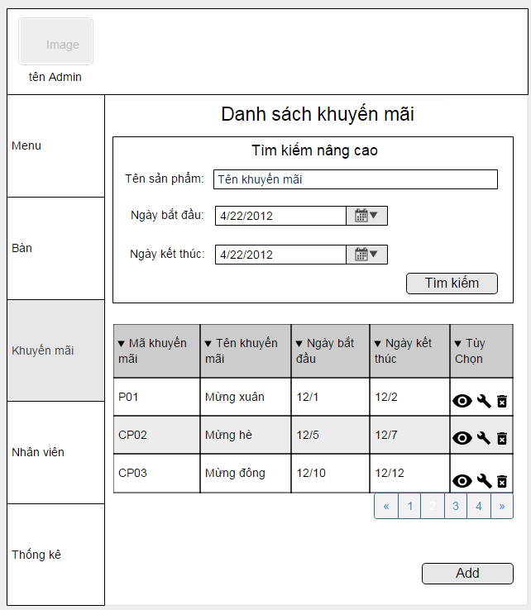

**Wireframes Description**

|  |  |  |  |
| --- | --- | --- | --- |
| No | Control Name | Control Type | Description |
|  | | | |
| 1 | “Tên sản phẩm” Label | Label |  |
| 2 | Product name | Textbox |  |
| 3 | “Ngày bắt đầu” Label | Label |  |
| 4 | Start date | Textbox |  |
| 5 | “Ngày kết thúc” Button | Label |  |
| 6 | End date | Textbox |  |
| 7 | “Tìm kiếm” button | Button |  |
| 8 | Promotion table | Table |  |
| 9 | “Add” button | Button |  |

### 3.1.20 Update Promotion

|  |  |
| --- | --- |
| Description | Manager want to update detail of promotion |
| Actor | Manager |
| Pre-condition | Manager login to system, access to Promotion Feature, and press on icon edit beside promotion information in table |
| Post-condition | Promotion details will be updated |
| Data Table | Promotion |
| Usage Frequency | Often | Regular | Low |
| Criticality | High | Normal | Low |
| Denpendencies | N/A |

**Activity Flow**

|  |  |
| --- | --- |
| Actor | System |
| 1. Manager press icon edit beside promotion item in product list | 2. System display dialog Update Promotion Information |
| 3. Manager input fields |  |
| 4. Manager press icon edit beside a product in promotion details | 5. System display dialog Update Promotion detail |
| 6. Manager press on button “Cập nhật” | 7. System update promotion information to database |
|  | 8. System show notification that promotion successfully updated |

**Alternative Flow**

* Not input all require field: system will notify manager “Vui lòng nhập các trường bắt buộc”.
* Invalid input: system will notify manager with each field have invalid input.

**Bussiness Rules**

|  |  |
| --- | --- |
| BR ID | Description |
| BR 1 | If manager have not input all required fields, system will show error |
| BR 2 | If have invalid field, system will show error below that field. |

**Wireframes**

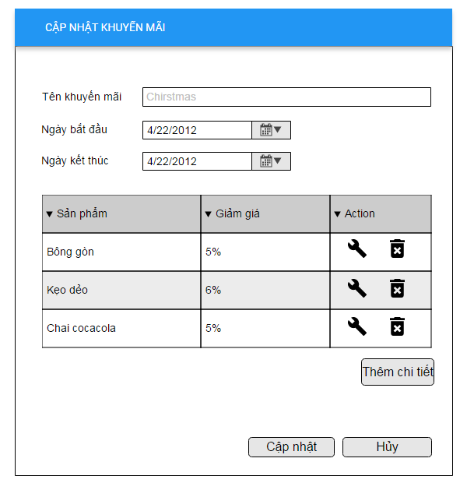

Wireframes 3.1.20.1 Update Promotion

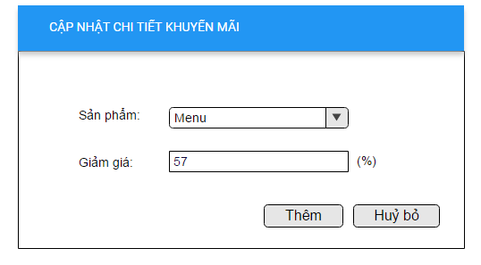

Wireframes 3.1.20.2 Update promtion detail

**Wireframes Description**

|  |  |  |  |
| --- | --- | --- | --- |
| No | Control Name | Control Type | Description |
|  | | | |
| 1 | “Tên khuyến mãi” Label | Label |  |
| 2 | Promotion name | Textbox |  |
| 3 | “Ngày bắt đầu” Label | Label |  |
| 4 | Start date | Textbox |  |
| 5 | “Ngày kết thúc” Label | Label |  |
| 6 | End date | Textbox |  |
| 7 | Promotion detail | Table |  |
| 8 | “Thêm chi tiết” button | Button |  |
| 9 | “Cập nhật” button | Button |  |
| 10 | “Hủy” button | Button |  |
| 11 | “Sản phẩm” Label | Label |  |
| 12 | Product | Combobox |  |
| 13 | “Giảm giá” Label | Label |  |
| 14 | Discount | Textbox |  |
| 15 | “Thêm” button | Button |  |
| 16 | “Hủy bỏ” button | Button |  |

### 3.1.21 Add Customer

|  |  |
| --- | --- |
| Description | Manager add new customer to system |
| Actor | Manager |
| Pre-condition | Manager login to system, access to Customer Feature, press on button “Thêm Khách Hàng” |
| Post-condition | New customer will be added to database |
| Data Table | Customer |
| Usage Frequency | Often | Regular | Low |
| Criticality | High | Normal | Low |
| Denpendencies | N/A |

**Activity Flow**

|  |  |
| --- | --- |
| Actor | System |
| 1. Manager access to application |  |
| 2. Manager access to Customer Feature | 3. System display Customer Screen |
| 4. Manager press on button “Thêm Khách Hàng” | 5. System display Add New Customer Dialog |
| 6. Manager input all require fields |  |
| 7. Manager press on button “Lưu” | 8. System save new customer to database |
|  | 9. System show dialog to notify successfully |

**Alternative Flow**

* Not input all require field: system will notify manager “Vui lòng nhập các trường bắt buộc”.
* Invalid input: system will notify manager with each field have invalid input.

**Bussiness Rules**

|  |  |
| --- | --- |
| BR ID | Description |
| BR 1 | If manager have not input all required fields, system will show error |
| BR 2 | If have invalid field, system will show error below that field. |

**Wireframes**

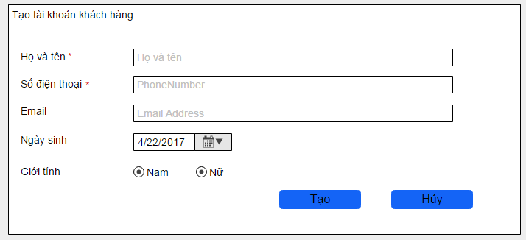

Wireframes 3.1.21 Add Customer

**Wireframes Description**

|  |  |  |  |
| --- | --- | --- | --- |
| No | Control Name | Control Type | Description |
|  | | | |
| 1 | “Họ và tên” Label | Label |  |
| 2 | Employee Name | Textbox |  |
| 3 | “Số điện thoại” Label | Label |  |
| 4 | Phone number | Textbox |  |
| 5 | “Email” Label | Label |  |
| 6 | Email | Textbox |  |
| 7 | “Ngày sinh” Label | Label |  |
| 8 | Birthday | Textbox |  |
| 9 | “Giới tính” Label | Label |  |
| 10 | Gender | Radio Button |  |
| 11 | “Tạo” button | Button |  |
| 12 | “Hủy” button | Button |  |

### 3.1.22 Search Customer Information

|  |  |
| --- | --- |
| Description | Manager search for customer information |
| Actor | Manager |
| Pre-condition | Manager login to system, access to Customer Feature |
| Post-condition | System display list customer on table |
| Data Table | Customer |
| Usage Frequency | Often | Regular | Low |
| Criticality | High | Normal | Low |
| Denpendencies | N/A |

**Activity Flow**

|  |  |
| --- | --- |
| Actor | System |
| 1. Manager access to application |  |
| 2. Manager access to Customer Feature | 3. System display Customer Screen |
| 4. Manager input to filter fields (not require) |  |
| 5. Manager press on button “Tìm kiếm” | 6. System search on database by filter fields |
|  | 7. System show customers on list view |

**Alternative Flow**

* Not found customer: System will show message under header of the list view.

**Bussiness Rules**

N/A

**Wireframes**

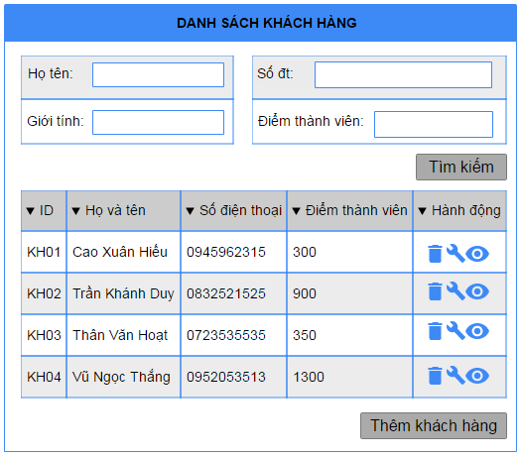

Wireframes 3.1.22 Search Customer

**Wireframes Description**

|  |  |  |  |
| --- | --- | --- | --- |
| No | Control Name | Control Type | Description |
|  | | | |
| 1 | “Họ và tên” Label | Label |  |
| 2 | Customer name | Textbox |  |
| 3 | “Số điện thoại” Label | Label |  |
| 4 | Phone number | Textbox |  |
| 5 | “Giới tính” Label | Label |  |
| 6 | Gender | Textbox |  |
| 7 | “Điểm thành viên” Label | Label |  |
| 8 | Gender | Textbox |  |
| 9 | Customer Table | Table |  |
| 10 | “Hủy” button | Button |  |
| 11 | “Thêm” button | Button |  |

### 3.1.23 Update Customer Information

|  |  |
| --- | --- |
| Description | Manager update customer information |
| Actor | Manager |
| Pre-condition | Manager login to system, access to Customer Feature, and press on icon edit beside customer in table |
| Post-condition | Customer information updated |
| Data Table | Customer |
| Usage Frequency | Often | Regular | Low |
| Criticality | High | Normal | Low |
| Denpendencies | N/A |

**Activity Flow**

|  |  |
| --- | --- |
| Actor | System |
| 1. Manager press icon edit beside customer item in product list | 2. System display dialog Update Customer Information |
| 3. Manager input fields |  |
| 4. Manager press on button “Lưu” | 7. System update customer information to database |
|  | 8. System show notification that customer information successfully updated |

**Alternative Flow**

* Not input all require field: system will notify manager “Vui lòng nhập các trường bắt buộc”.
* Invalid input: system will notify manager with each field have invalid input.
* Phone number already exists: system will notify manager that phone number already exists in the system

**Bussiness Rules**

|  |  |
| --- | --- |
| BR ID | Description |
| BR 1 | If manager have not input all required fields, system will show error |
| BR 2 | If have invalid field, system will show error below that field. |

**Wireframes**

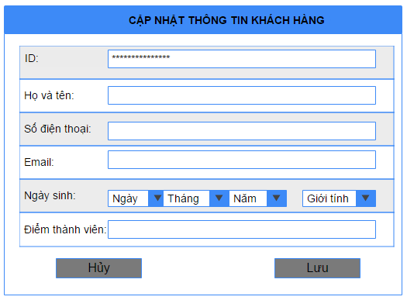

Wireframes 3.1.23 Update Customer Information

**Wireframes Description**

|  |  |  |  |
| --- | --- | --- | --- |
| No | Control Name | Control Type | Description |
|  | | | |
| 1 | “ID” Label | Label |  |
| 2 | Customer id | Textbox | Unable to update |
| 3 | “Họ và tên” Label | Label |  |
| 4 | Customer Name | Textbox |  |
| 5 | “Số điện thoại” Label | Label |  |
| 6 | Phone number | Textbox |  |
| 7 | “Email” Label | Label |  |
| 8 | Email | Textbox |  |
| 9 | “Ngày sinh” Label | Label |  |
| 10 | Product | Combobox |  |
| 11 | “Điểm thành viên” Label | Label |  |
| 12 | Member Point | Textbox |  |
| 13 | “Nam” “Nữ” Label | Label |  |
| 14 | Gender | RadioBox |  |
| 15 | “Lưu” button | Button |  |
| 16 | “Hủy” button | Button |  |

### 3.1.24 Delete Customer

|  |  |
| --- | --- |
| Description | Manager delete a customer from database |
| Actor | Manager |
| Pre-condition | Manager login to system, access to Customer Feature, and press on icon delete beside customer in table |
| Post-condition | Customer is deleted from system |
| Data Table | Customer |
| Usage Frequency | Often | Regular | Low |
| Criticality | High | Normal | Low |
| Denpendencies | N/A |

**Activity Flow**

|  |  |
| --- | --- |
| Actor | System |
| 1. Manager press on icon delete beside customer item | 2. System show dialog to confirm delete |
| 3. Manager press on button “Xác nhận” | 4. System delete customer |
|  | 5. System notify customer successfully deleded |

**Alternative Flow**

* Manager press on Button “Không”: System will not delete customer .

**Bussiness Rules**

N/A

**Wireframes**

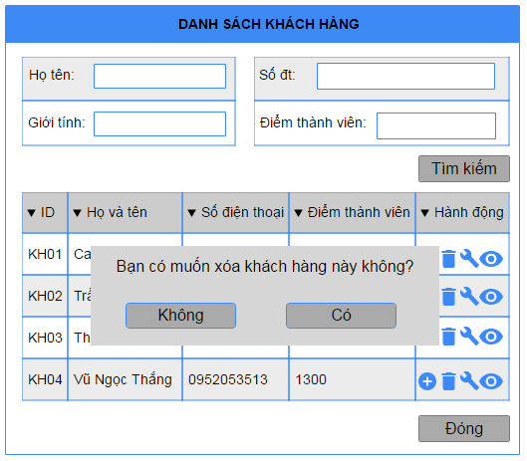

Wireframes 3.1.24 Delete Customer

**Wireframes Description**

|  |  |  |  |
| --- | --- | --- | --- |
| No | Control Name | Control Type | Description |
|  | | | |
| 1 | “Có” button | Button |  |
| 2 | “Không” button | Button |  |

### 3.1.25 Add Table

|  |  |
| --- | --- |
| Description | Manager add new table to their restaurant |
| Actor | Manager |
| Pre-condition | Manager login to system, access to Table Feature, and press on button “Thêm Mới” |
| Post-condition | New table added to datable |
| Data Table | Desk |
| Usage Frequency | Often | Regular | Low |
| Criticality | High | Normal | Low |
| Denpendencies | N/A |

**Activity Flow**

|  |  |
| --- | --- |
| Actor | System |
| 1. Manager access to application |  |
| 2. Manager access to Table Feature | 3. System display Table Screen |
| 4. Manager press on button “Thêm Mới” | 5. System display Add New Table Dialog |
| 6. Manager input all require fields |  |
| 7. Manager press on button “Thêm” | 8. System save new table information to database |
|  | 9. System show dialog to notify successfully |

**Alternative Flow**

* Not input all require field: system will notify manager “Vui lòng nhập các trường bắt buộc”.
* Invalid input: system will notify manager with each field have invalid input

**Bussiness Rules**

|  |  |
| --- | --- |
| BR ID | Description |
| BR 1 | If manager have not input all required fields, system will show error |
| BR 2 | If have invalid field, system will show error below that field. |

**Wireframes**

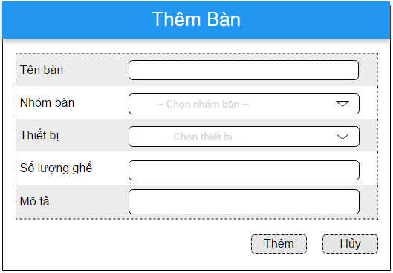

Wireframes 3.1.25 Add Table

**Wireframes Description**

|  |  |  |  |
| --- | --- | --- | --- |
| No | Control Name | Control Type | Description |
|  | | | |
| 1 | “Nhóm bàn” Label | Label |  |
| 2 | Group Table Id | ComboBox |  |
| 3 | “Tên bàn” Label | Label |  |
| 4 | Table Name | Textbox |  |
| 5 | “Mã thiết bị” Label | Label |  |
| 6 | Device Id | Textbox |  |
| 7 | “Số lượng ghế” Label | Label |  |
| 8 | Chair Quantity | Textbox |  |
| 9 | “Mô tả” Label | Label |  |
| 10 | Description | Textbox |  |
| 11 | “Thêm” button | Button |  |
| 12 | “Hủy” button | Button |  |

### 3.1.26 Search Table

|  |  |
| --- | --- |
| Description | Search for table information |
| Actor | Manager |
| Pre-condition | Manager login to system, access to Table Feature |
| Post-condition | List table of restaurant show in table |
| Data Table | Desk |
| Usage Frequency | Often | Regular | Low |
| Criticality | High | Normal | Low |
| Denpendencies | N/A |

**Activity Flow**

|  |  |
| --- | --- |
| Actor | System |
| 1. Manager access to application |  |
| 2. Manager access to Table Feature | 3. System display Table Screen |
| 4. Manager input to filter fields (not require) |  |
| 5. Manager press on button “Tìm kiếm” | 6. System search on database by filter fields |
|  | 7. System show tables on list view |

**Alternative Flow**

* Not found table: System will show message under header of the list view.

**Bussiness Rules**

N/A

**Wireframes**

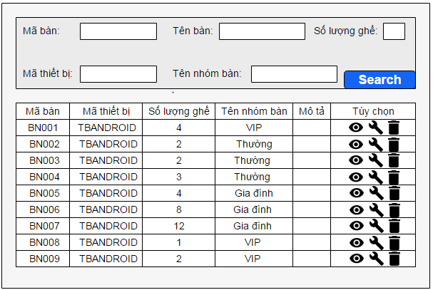

Wireframes 3.1.26 Search Table

**Wireframes Description**

|  |  |  |  |
| --- | --- | --- | --- |
| No | Control Name | Control Type | Description |
|  | | | |
| 1 | “Mã bàn” Label | Label |  |
| 2 | Table Id | ComboBox |  |
| 3 | “Tên nhóm bàn” Label | Label |  |
| 4 | Group Table Name | Textbox |  |
| 5 | “Mã thiết bị” Label | Label |  |
| 6 | Device Id | Textbox |  |
| 7 | “Số lượng ghế” Label | Label |  |
| 8 | Chair Quantity | Textbox |  |
| 9 | “Tên bàn” Label | Label |  |
| 10 | Table Name | Textbox |  |
| 11 | Table list | Table |  |
| 12 | “Tìm kiếm” button | Button |  |
| 13 | “Thêm mới” button | Button |  |

### 3.1.27 Update Table

|  |  |
| --- | --- |
| Description | Manager update table information |
| Actor | Manager |
| Pre-condition | Manager login to system, access to Table Feature, and press on icon edit beside table in table list |
| Post-condition | Table information updated |
| Data Table | Desk |
| Usage Frequency | Often | Regular | Low |
| Criticality | High | Normal | Low |
| Denpendencies | N/A |

**Activity Flow**

|  |  |
| --- | --- |
| Actor | System |
| 1. Manager press icon edit beside table item in product list | 2. System display dialog Update Table Information |
| 3. Manager input fields |  |
| 4. Manager press on button “Lưu” | 7. System update table information to database |
|  | 8. System show notification that table information successfully updated |

**Alternative Flow**

* Not input all require field: system will notify manager “Vui lòng nhập các trường bắt buộc”.
* Invalid input: system will notify manager with each field have invalid input.
* Phone number already exists: system will notify manager that phone number already exists in the system

**Bussiness Rules**

|  |  |
| --- | --- |
| BR ID | Description |
| BR 1 | If manager have not input all required fields, system will show error |
| BR 2 | If have invalid field, system will show error below that field. |

**Wireframes**

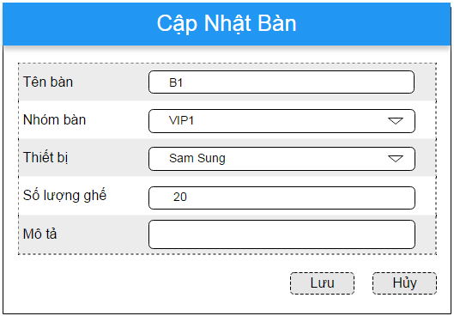

Wireframes 3.1.27 Update Table

**Wireframes Description**

|  |  |  |  |
| --- | --- | --- | --- |
| No | Control Name | Control Type | Description |
|  | | | |
| 1 | “Mã nhóm bàn” Label | Label |  |
| 2 | Table Id | ComboBox | Unable to update |
| 3 | “Tên bàn” Label | Label |  |
| 4 | Table Name | Textbox |  |
| 5 | “Mã thiết bị” Label | Label |  |
| 6 | Device Id | Textbox |  |
| 7 | “Số lượng ghế” Label | Label |  |
| 8 | Chair Quantity | Textbox |  |
| 9 | “Mô tả” Label | Label |  |
| 10 | Description | Textbox |  |
| 11 | “Lưu” button | Button |  |
| 12 | “Hủy” button | Button |  |

### 3.1.28 Delete Table

|  |  |
| --- | --- |
| Description | Manager delete a table from system |
| Actor | Manager |
| Pre-condition | Manager login to system, access to Table Feature, and press on icon delete beside table item in table list |
| Post-condition | Customer is deleted from system |
| Data Table | Desk |
| Usage Frequency | Often | Regular | Low |
| Criticality | High | Normal | Low |
| Denpendencies | N/A |

**Activity Flow**

|  |  |
| --- | --- |
| Actor | System |
| 1. Manager press on icon delete beside table item | 2. System show dialog to confirm delete |
| 3. Manager press on button “Đồng ý” | 4. System delete table |
|  | 5. System notify table successfully deleded |

**Alternative Flow**

* Manager press on Button “Hủy”: System will not delete table.

**Bussiness Rules**

N/A

**Wireframes**

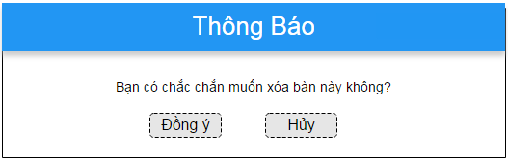

Wireframes 3.1.28 Delete Table

**Wireframes Description**

|  |  |  |  |
| --- | --- | --- | --- |
| No | Control Name | Control Type | Description |
|  | | | |
| 1 | “Đồng ý” button | Button |  |
| 2 | “Hủy” button | Button |  |

### 3.1.29 Add Group Table

|  |  |
| --- | --- |
| Description | Manager add new table to their restaurant |
| Actor | Manager |
| Pre-condition | Manager login to system, access to Group Table Feature, and press on button “Thêm Mới” |
| Post-condition | New group table added to datable |
| Data Table | Group Desk |
| Usage Frequency | Often | Regular | Low |
| Criticality | High | Normal | Low |
| Denpendencies | N/A |

**Activity Flow**

|  |  |
| --- | --- |
| Actor | System |
| 1. Manager access to application |  |
| 2. Manager access to Group Table Feature | 3. System display Group Table Screen |
| 4. Manager press on button “Thêm Mới” | 5. System display Add New Group Table Dialog |
| 6. Manager input all require fields |  |
| 7. Manager press on button “Thêm” | 8. System save new group table information to database |
|  | 9. System show dialog to notify successfully |

**Alternative Flow**

* Not input all require field: system will notify manager “Vui lòng nhập các trường bắt buộc”.
* Invalid input: system will notify manager with each field have invalid input

**Bussiness Rules**

|  |  |
| --- | --- |
| BR ID | Description |
| BR 1 | If manager have not input all required fields, system will show error |
| BR 2 | If have invalid field, system will show error below that field. |

**Wireframes**

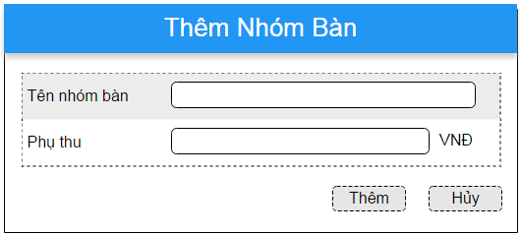

Wireframes 3.1.25 Add Group Table

**Wireframes Description**

|  |  |  |  |
| --- | --- | --- | --- |
| No | Control Name | Control Type | Description |
|  | | | |
| 1 | “Tên nhóm bàn” Label | Label |  |
| 2 | Group Table Name | Textbox |  |
| 3 | “Phụ thu” Label | Label |  |
| 4 | Additonally levied | Textbox |  |
| 5 | “Thêm” button | Button |  |
| 6 | “Hủy” button | Button |  |

### 3.1.30 Search Group Table

|  |  |
| --- | --- |
| Description | Search for group table information |
| Actor | Manager |
| Pre-condition | Manager login to system, access to Group Table Feature |
| Post-condition | List group table of restaurant show in table |
| Data Table | Group Desk |
| Usage Frequency | Often | Regular | Low |
| Criticality | High | Normal | Low |
| Denpendencies | N/A |

**Activity Flow**

|  |  |
| --- | --- |
| Actor | System |
| 1. Manager access to application |  |
| 2. Manager access to Group Table Feature | 3. System display Group Table Screen |
| 4. Manager input to filter fields (not require) |  |
| 5. Manager press on button “Tìm kiếm” | 6. System search on database by filter fields |
|  | 7. System show group tables on list view |

**Alternative Flow**

* Not found group tables: System will show error message under header of the list view.

**Bussiness Rules**

N/A

**Wireframes**

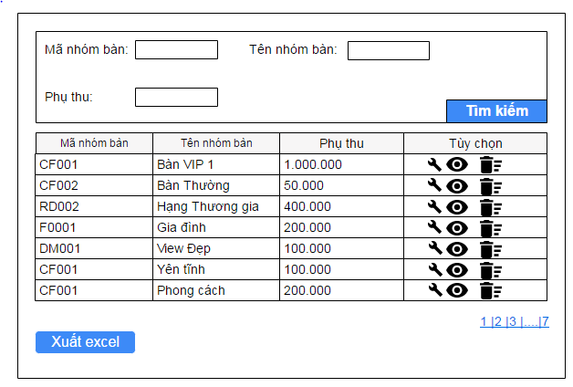

Wireframes 3.1.30 Search Group Table

**Wireframes Description**

|  |  |  |  |
| --- | --- | --- | --- |
| No | Control Name | Control Type | Description |
|  | | | |
| 1 | “Mã nhóm bàn” Label | Label |  |
| 2 | Group Table Id | ComboBox |  |
| 3 | “Tên nhóm bàn” Label | Label |  |
| 4 | Group Table Name | Textbox |  |
| 5 | “Phụ thu” Label | Label |  |
| 6 | Additonally Levied | Textbox |  |
| 7 | Group Table list | Table |  |
| 8 | “Tìm kiếm” button | Button |  |
| 9 | “Thêm mới” button | Button |  |

### 3.1.31 Update Group Table

|  |  |
| --- | --- |
| Description | Manager update information of group table |
| Actor | Manager |
| Pre-condition | Manager login to system, access to Group Table Feature and press on icon edit beside group table item in list |
| Post-condition | Group table information updated |
| Data Table | Group Desk |
| Usage Frequency | Often | Regular | Low |
| Criticality | High | Normal | Low |
| Denpendencies | N/A |

**Activity Flow**

|  |  |
| --- | --- |
| Actor | System |
| 1. Manager press icon edit beside group table item in product list | 2. System display dialog Update Group Table Information |
| 3. Manager input fields |  |
| 4. Manager press on button “Lưu” | 7. System update group table information to database |
|  | 8. System show notification successfully updated |

**Alternative Flow**

* Not input all require field: system will notify manager “Vui lòng nhập các trường bắt buộc”.
* Invalid input: system will notify manager with each field have invalid input.
* Phone number already exists: system will notify manager that phone number already exists in the system

**Bussiness Rules**

|  |  |
| --- | --- |
| BR ID | Description |
| BR 1 | If manager have not input all required fields, system will show error |
| BR 2 | If have invalid field, system will show error below that field. |

**Wireframes**

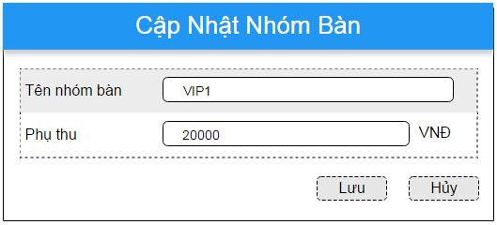

Wireframes 3.1.31 Update Group Table

**Wireframes Description**

|  |  |  |  |
| --- | --- | --- | --- |
| No | Control Name | Control Type | Description |
|  | | | |
| 1 | “Tên nhóm bàn” Label | Label |  |
| 2 | Table Id | ComboBox | Unable to update |
| 3 | “Phụ thu” Label | Label |  |
| 4 | Additonally levied | Textbox |  |
| 5 | “Lưu” button | Button |  |
| 6 | “Hủy” button | Button |  |

### 3.1.32 Delete Group Table

|  |  |
| --- | --- |
| Description | Manager delete a group table from their system |
| Actor | Manager |
| Pre-condition | Manager login to system, access to Group Table Feature, and press on icon delete beside group table item in list |
| Post-condition | Group table is deleted from system |
| Data Table | Group Table |
| Usage Frequency | Often | Regular | Low |
| Criticality | High | Normal | Low |
| Denpendencies | N/A |

**Activity Flow**

|  |  |
| --- | --- |
| Actor | System |
| 1. Manager press on icon delete beside group table item | 2. System show dialog to confirm delete |
| 3. Manager press on button “Đồng ý” | 4. System delete group table |
|  | 5. System notify group table successfully deleded |

**Alternative Flow**

* Manager press on Button “Hủy”: System will not delete group table.

**Bussiness Rules**

N/A

**Wireframes**

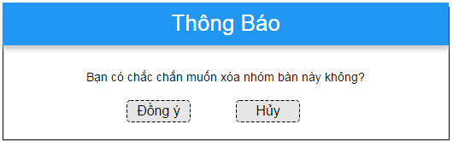

Wireframes 3.1.28 Delete Table

**Wireframes Description**

|  |  |  |  |
| --- | --- | --- | --- |
| No | Control Name | Control Type | Description |
|  | | | |
| 1 | “Đồng ý” button | Button |  |
| 2 | “Hủy” button | Button |  |

### 3.1.33 Create Goods Receipt

|  |  |
| --- | --- |
| Description | Manager create a new goods receipt |
| Actor | Manager |
| Pre-condition | Manager login to system, access to Goods Receipt Feature, and press on button “Thêm hàng” |
| Post-condition | New goods receipt created |
| Data Table | Store |
| Usage Frequency | Often | Regular | Low |
| Criticality | High | Normal | Low |
| Denpendencies | N/A |

**Activity Flow**

|  |  |
| --- | --- |
| Actor | System |
| 1. Manager access to application |  |
| 2. Manager access to Goods Receipt Feature | 3. System display Goods Receipt Screen |
| 4. Manager press on button “Thêm Mới” | 5. System display Add New Goods Receipt Dialog |
| 6. Manager input all require fields |  |
| 7. Manager press on button “Lưu” | 8. System save new goods receipt information to database |
|  | 9. System show dialog to notify successfully |

**Alternative Flow**

* Not input all require field: system will notify manager “Vui lòng nhập các trường bắt buộc”.
* Invalid input: system will notify manager with each field have invalid input

**Bussiness Rules**

|  |  |
| --- | --- |
| BR ID | Description |
| BR 1 | If manager have not input all required fields, system will show error |
| BR 2 | If have invalid field, system will show error below that field. |

**Wireframes**

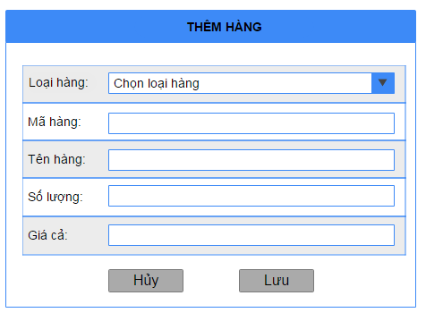

Wireframes 3.1.33 Create Goods Receipt

**Wireframes Description**

|  |  |  |  |
| --- | --- | --- | --- |
| No | Control Name | Control Type | Description |
|  | | | |
| 1 | “Loại hàng” Label | Label |  |
| 2 | Material Type | Textbox |  |
| 3 | “Mã hàng” Label | Label |  |
| 4 | Material Id | Textbox |  |
| 5 | “Tên hàng” Label | Label |  |
| 6 | Material Name | TextBox |  |
| 7 | “Số lượng” Label | Label |  |
| 8 | Quantity | TextBox |  |
| 9 | “Giá” Label | Label |  |
| 10 | Price | TextBox |  |
| 11 | “Lưu” button | Button |  |
| 12 | “Hủy” button | Button |  |

### 3.1.34 Show Goods Receipt

|  |  |
| --- | --- |
| Description | Manager search for goods receipt data in system |
| Actor | Manager |
| Pre-condition | Manager login to system, access to Goods Receipt Feature |
| Post-condition | List goods receipt of restaurant and show in table |
| Data Table | Store |
| Usage Frequency | Often | Regular | Low |
| Criticality | High | Normal | Low |
| Denpendencies | N/A |

**Activity Flow**

|  |  |
| --- | --- |
| Actor | System |
| 1. Manager access to application |  |
| 2. Manager access to Goods Receipt Feature | 3. System display Goods Receipt Screen |
| 4. Manager input to filter fields (not require) |  |
| 5. Manager press on button “Search” | 6. System search on database by filter fields |
|  | 7. System show receipts on list view |

**Alternative Flow**

* Not found receipt: System will show message under header of the list view.

**Bussiness Rules**

N/A

**Wireframes**

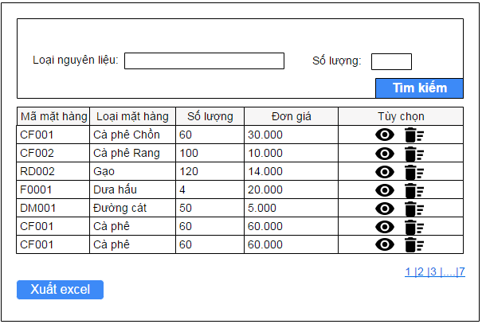

Wireframes 3.1.34 Show Goods Receipt

**Wireframes Description**

|  |  |  |  |
| --- | --- | --- | --- |
| No | Control Name | Control Type | Description |
|  | | | |
| 1 | “Loại nguyên liệu” Label | Label |  |
| 2 | Material Type | Textbox |  |
| 3 | “Số lượng” Label | Label |  |
| 4 | Quantity | Textbox |  |
| 5 | Receipt list | Table |  |
| 6 | “Search” button | Button |  |
| 7 | “Xuất Excel” button | Button |  |

### 3.1.35 Show Goods Receipt Detail

|  |  |
| --- | --- |
| Description | Manager want to see detail of goods receipt |
| Actor | Manager |
| Pre-condition | Manager login to system, access to Goods Receipt Feature, and press on icon View beside receipt in table |
| Post-condition | System show dialog detail of Receipt |
| Data Table | Store |
| Usage Frequency | Often | Regular | Low |
| Criticality | High | Normal | Low |
| Denpendencies | N/A |

**Activity Flow**

|  |  |
| --- | --- |
| Actor | System |
| 1. Manager press icon view beside receipt item in table | 2. System display dialog detail of receipt |

**Alternative Flow**

N/A

**Bussiness Rules**

N/A

**Wireframes**

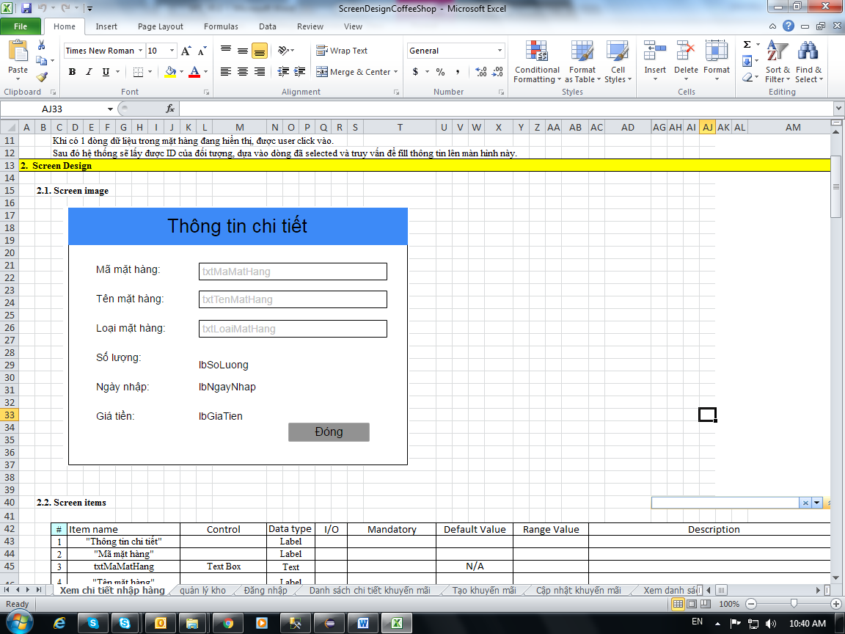

Wireframes 3.1.34 Show Goods Receipt Detail

**Wireframes Description**

|  |  |  |  |
| --- | --- | --- | --- |
| No | Control Name | Control Type | Description |
|  | | | |
| 1 | “Mã mặt hàng” Label | Label |  |
| 2 | Material Id | Label |  |
| 3 | “Tên mặt hàng” Label | Label |  |
| 4 | Material Name | Label |  |
| 5 | “Loại mặt hàng” | Label |  |
| 6 | Material Type | Label |  |
| 7 | “Số lượng” | Label |  |
| 8 | Quantity | Label |  |
| 9 | “Ngày nhập” | Label |  |
| 10 | Date | Label |  |
| 11 | “Gía tiền” | Label |  |
| 12 | Price | Label |  |
| 13 | “Đóng” button | Button |  |

### 3.1.36 Update Goods Receipt

|  |  |
| --- | --- |
| Description | Manager update information of goods receipt |
| Actor | Manager |
| Pre-condition | Manager login to system, access to Goods Receipt Feature and press on icon edit beside receipt item in list |
| Post-condition | Receipt updated |
| Data Table | Store |
| Usage Frequency | Often | Regular | Low |
| Criticality | High | Normal | Low |
| Denpendencies | N/A |

**Activity Flow**

|  |  |
| --- | --- |
| Actor | System |
| 1. Manager press icon edit receipt item in product list | 2. System display dialog Update Receipt Information |
| 3. Manager input fields |  |
| 4. Manager press on button “Lưu” | 7. System update receipt information to database |
|  | 8. System show notification successfully updated |

**Alternative Flow**

* Not input all require field: system will notify manager “Vui lòng nhập các trường bắt buộc”.
* Invalid input: system will notify manager with each field have invalid input.

**Bussiness Rules**

|  |  |
| --- | --- |
| BR ID | Description |
| BR 1 | If manager have not input all required fields, system will show error |
| BR 2 | If have invalid field, system will show error below that field. |

**Wireframes**

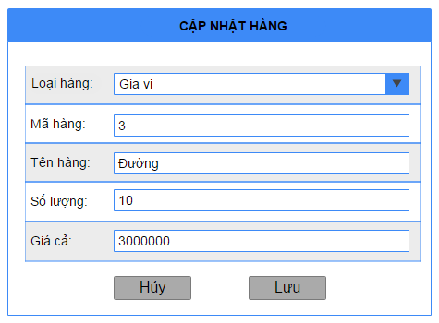

Wireframes 3.1.36 Update Goods Receipt

**Wireframes Description**

|  |  |  |  |
| --- | --- | --- | --- |
| No | Control Name | Control Type | Description |
|  | | | |
| 1 | “Loại hàng” Label | Label |  |
| 2 | Material Type | ComboBox |  |
| 3 | “Mã hàng” Label | Label |  |
| 4 | Material Id | Textbox | Unable to update |
| 5 | “Tên hàng” Label | Label |  |
| 6 | Material Name | Textbox |  |
| 7 | “Số lượng” Label | Label |  |
| 8 | Quantity | Textbox |  |
| 9 | “Giá cả” Label | Label |  |
| 10 | Price | Textbox |  |
| 11 | “Lưu” button | Button |  |
| 12 | “Hủy” button | Button |  |

### 3.1.37 Delete Goods Receipt

|  |  |
| --- | --- |
| Description | Manager delete a receipt |
| Actor | Manager |
| Pre-condition | Manager login to system, access to Goods Receipt Feature, and press on icon delete beside receipt item in list |
| Post-condition | Receipt is deleted from system |
| Data Table | Store |
| Usage Frequency | Often | Regular | Low |
| Criticality | High | Normal | Low |
| Denpendencies | N/A |

**Activity Flow**

|  |  |
| --- | --- |
| Actor | System |
| 1. Manager press on icon delete beside receipt item | 2. System show dialog to confirm delete |
| 3. Manager press on button “OK” | 4. System delete receipt |
|  | 5. System notify receipt successfully deleded |

**Alternative Flow**

* Manager press on Button “Cancel”: System will not delete receipt.

**Bussiness Rules**

N/A

**Wireframes**

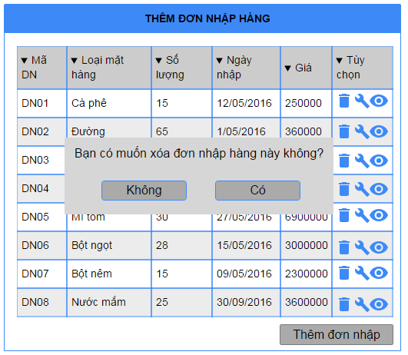

Wireframes 3.1.37 Delete Goods Receipt

**Wireframes Description**

|  |  |  |  |
| --- | --- | --- | --- |
| No | Control Name | Control Type | Description |
|  | | | |
| 1 | “OK” button | Button |  |
| 2 | “Cancel” button | Button |  |

### 3.1.38 Show Bill Detail

|  |  |
| --- | --- |
| Description | Manager see the bill that they sell |
| Actor | Manager |
| Pre-condition | Manager login to system, access to Bill Feature |
| Post-condition | System show bill information |
| Data Table | Orders |
| Usage Frequency | Often | Regular | Low |
| Criticality | High | Normal | Low |
| Denpendencies | N/A |

**Activity Flow**

|  |  |
| --- | --- |
| Actor | System |
| 1. Manager access to application |  |
| 2. Manager access to Bill Feature | 3. System display Bill Management Screen |
| 4. Manager input to filter fields (not require) |  |
| 5. Manager press on button “Search” | 6. System search on database by filter fields |
|  | 7. System show bills on list view |
| 8. Manager press on icon Show on item | 9. System show dialog bill item information |

**Alternative Flow**

* Not found receipt: System will show message under header of the list view.

**Bussiness Rules**

N/A

**Wireframes**

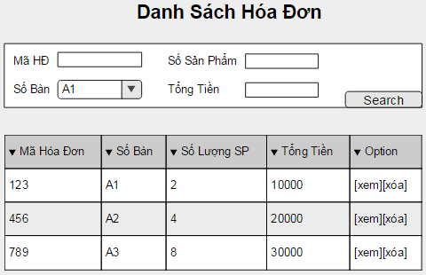

Wireframes 3.1.38.1 Search Bill

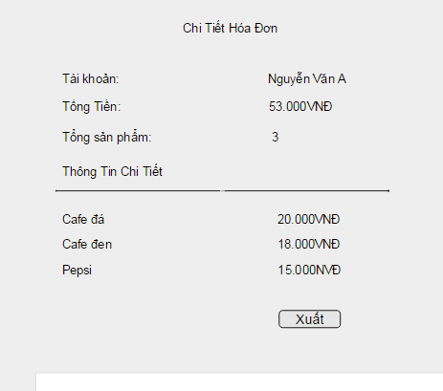

Wireframes 3.1.38 Bill Detail

**Wireframes Description**

|  |  |  |  |
| --- | --- | --- | --- |
| No | Control Name | Control Type | Description |
|  | | | |
| 1 | “Mã HĐ” Label | Label |  |
| 2 | Bill Id | Textbox |  |
| 3 | “Số sản phẩm” Label | Label |  |
| 4 | Product Quantity | Textbox |  |
| 5 | “Số Bàn” Label | Label |  |
| 6 | Desk Quantity | Textbox |  |
| 7 | “Tổng tiền” Label | Label |  |
| 8 | Total Price | Textbox |  |
| 9 | “Search” Button | Button |  |
| 10 | Bill Table | Table |  |
| 11 | “Tài khoản” Label | Label |  |
| 12 | Account | Label |  |
| 13 | “Tổng tiền” Label | Label |  |
| 14 | Total price | Label |  |
| 15 | “Tổng sản phẩm” | Label |  |
| 16 | Total product | Label |  |
| 17 | Bill detail table | Table |  |
| 18 | “Đóng” button | Button |  |

## 3.2 Usability

## 3.3 Reliability

## 3.4 Performance

## 3.5 Supportability

## 3.6 Design Constraints

## 3.7 On-line User Documentation and Help System Requirements

## 3.8 Interfaces

## 3.9 Licensing Requirements

## 3.10 Legal, Copyright, and Other Notices

## 3.11 Applicable Standards

# 4. Supporting Information